**REFS TO PERSIST DATA BETWEEN RENDERS**

**In React, the useRef hook is often used to persist data between renders without causing a re-render when the data changes. Unlike the useState hook, changes to the current property of a ref do not trigger a re-render. This makes it useful for holding mutable values that you don't want to cause a component to re-render when they change.**

**Remember that while useRef allows you to persist data between renders without causing re-renders, it doesn't trigger re-renders on its own. If you need to trigger a re-render when data changes, you might want to use useState instead.**

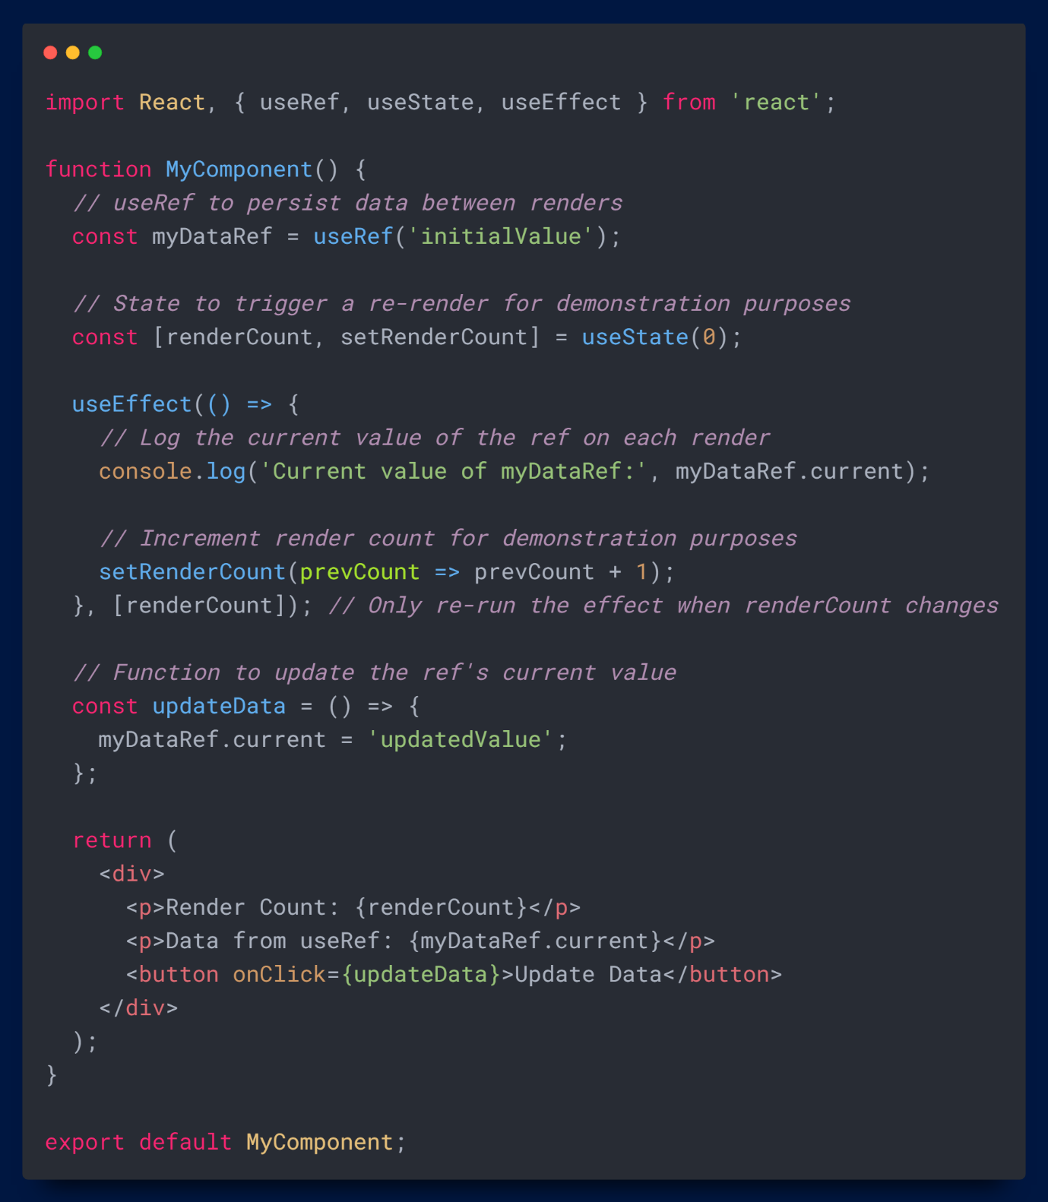

**Do you find it helpful?**

**Let me know down in the comments.**



[](https://www.linkedin.com/in/anubhav-gupta-b68946132/)

**Click To Follow For More On LinkedIN**